First and Follow

# 

# Submitted to:

* Dr. Talha Waheed

# Submitted by:

* Komal Shehzadi (2016-CS-178)

# Department of Computer Science and Engineering

# UET Lahore





**IN MANUAL FORMAT:**

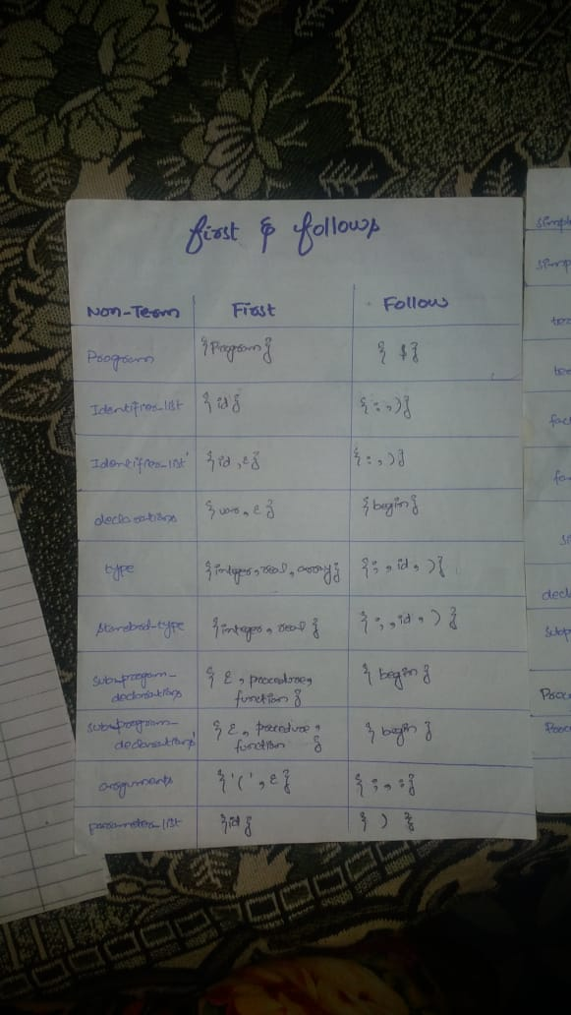

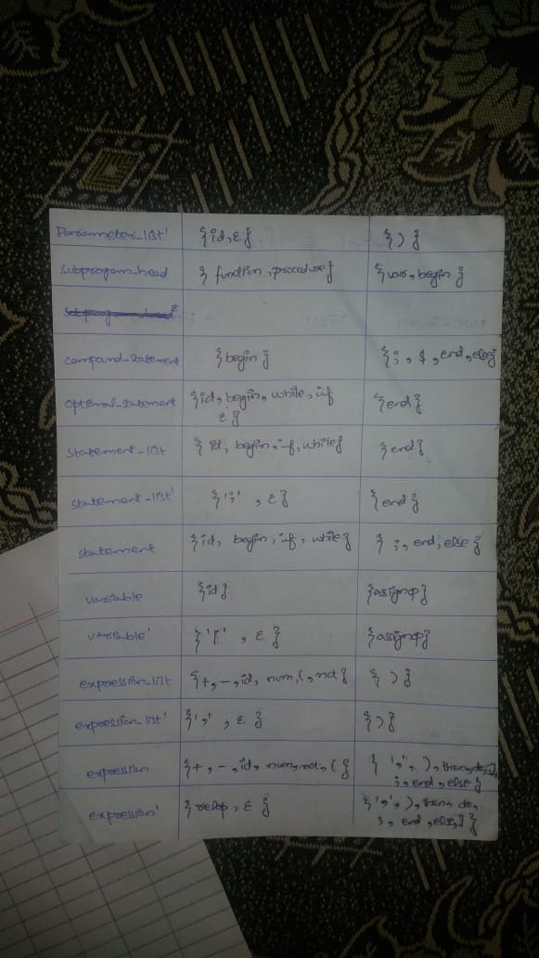

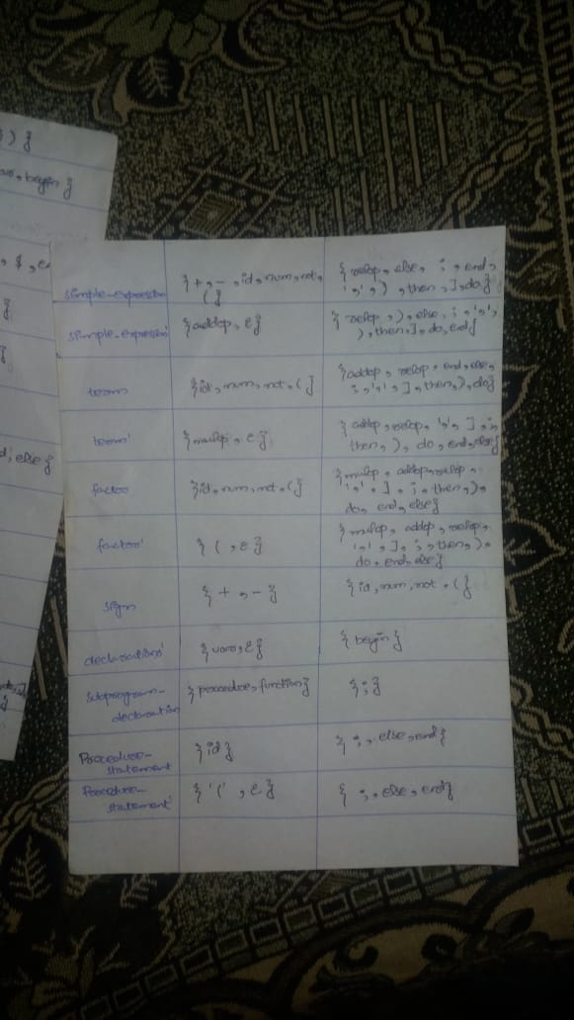

**IN WORD TABLE:**

|  |  |  |  |
| --- | --- | --- | --- |
| **#** | **non-terminals** | **first** | **follow** |
|  | PROGRAM | {**program**} | {**$**} |
|  | identifier_list | {**id**} | {**)**, **:**} |
|  | identifier_list’ | {**,**, } | {**)**, **:**} |
|  | declarations | {**var**, } | {**function**, **procedure**, **begin**} |
|  | declarations’ | {**var**, } | {**function**, **procedure**, **begin**} |
|  | type | {**integer**, **real**, **array**} | {**;**, **)**} |
|  | standard_type | {**integer**, **real**} | {**;**, **)**} |
|  | subprogram_declarations | {**function**, **procedure**, } | {**begin**} |
|  | subprogram_declarations’ | {**function**, **procedure**, } | {**begin**} |
|  | subprogram_declaration | {**function**, **procedure**} | {**;**} |
|  | subprogram_head | {**function**, **procedure**} | {**var**, **begin**} |
|  | arguments | {**(**, } | {**:**, **;**} |
|  | parameter_list | {**id**} | {**)**} |
|  | parameter_list’ | {**;**, } | {**)**} |
|  | compound_statement | {**begin**} | {**$**, **;**, **else, end**} |
|  | optional_statements | {**id**, **begin**, **if**, **while**, } | {**end**} |
|  | statement_list | {**id**, **begin**, **if**, **while**} | {**end**} |
|  | statement_list’ | {**;,** } | {**end**} |
|  | statement | {**id**, **begin**, **if**, **while**} | {**;**, **else**, **end**} |
|  | variable | {**id**} | {**assignop**} |
|  | variable’ | {**[**, } | {**assignop**} |
|  | procedure_statement | {**id**} | {**;**, **else**, **end**} |
|  | procedure_statement’ | {**(**, } | {**;**, **else**, **end**} |
|  | expression_list | {**id**, **num**, **(**, **not**, **+**, **-**} | {**)**} |
|  | expression_list’ | {**,**, } | {**)**} |
|  | expression | {**id**, **num**, **(**, **not**, **+**, **-**} | {**;**, **else**, **end**, **then**, **do**, **]**, **,**, ****} |
|  | expression’ | {**relop**, } | {**;**, **else**, **end**, **then**, **do**, **]**, **,**, ****} |
|  | simple_expression | {**id**, **num**, **(**, **+**, **-**} | {**relop**, **;**, **else, end**, **then**, **do**, **]**, **,**, **** |
|  | simple_expression’ | {**addop,**  | {**relop**, **;**, **else, end**, **then**, **do**, **]**, **,**, **** |
|  | term | {**id**, **num**, **(**, **not**} | {**addop**, **relop**, **;**, **else, end**, **then**, **do**, **]**, **,**, **** |
|  | term’ | {**mulop**, } | {**addop**, **relop**, **;**, **else, end**, **then**, **do**, **]**, **,**, **** |
|  | factor | {**id**, **num**, **(**, **not**} | {**mulop**, **addop**, **relop**, **;**, **else, end**, **then**, **do**, **]**, **,**, **** |
|  | factor’ | {**(**, } | {**mulop**, **addop**, **relop**, **;**, **else, end**, **then**, **do**, **]**, **,**, **** |
|  | sign | {**+**, **-**} | {**id**, **num**, **(**, **not**} |